**Instructions:**Replace **[bracketed red text]** with the requested information or screen capture.  
Replace **bracketed red text with black text**.  
**PLEASE do not include full page, full window screen shot images**, or full screen shots that have been reduced in size.

Please do not work the assignment and the tutorial at the same time.   
  
Use a snippet tool to capture parts of the screen and insert those images into the template.  
**Do not remove tags from this template. An example of a tag is [C01]. All fields are required.***Please do not alter template formatting or delete parts of this template.*

Part A - Student Information:   
 **1. Student Name: Abel Marin  
2. Student email? Marinabe1416@gmail.com**  
Go back to the instructions and continue with Part B.Part B – Drupal CMS Website and Web Host Information:

**Part B.1 – Drupal 8 on a Shared web host**

1. Enter the following shared web host Drupal site information **[B.1.1]**
   1. Shared Web Host Company Name: [ SiteGround ]
   2. In Directory Name: [ tutorial07 ]
   3. Website Admin Username: [ ajmarin ]
   4. Website Admin Password: [ QTTo4#%XXJ ]
   5. Database Name: [ drup697 ]
   6. Table Prefix: [ dryl\_ ]

**Shared Web Host OR Pantheon**

**Part B.2 – Drupal 8 on Pantheon (PaaS)**

1. Enter the following shared web host Drupal 8 site information **[B.2.1]**
   1. PaaS Drupal 8 Front end site URL: [ website URL here ]
   2. PaaS Drupal 8 site Admin Username: [ website admin username here ]
   3. PaaS Drupal 8 site Admin Password: [ website admin password here ]

**Part B.3 – Drupal 8 on Codeanywhere**

1. Enter the following Codeanywhere web host Drupal 8 site information **[B.3.1]**
   1. Codeanywhere account username(email): [marinabe1416@gmail.com]
   2. Codeanywhere account password: [Dbeu!315]
   3. Site Title: [ AJM - Drupal 8 - Test 123]
   4. Username: [ ajmarin ]
   5. Password: [ Dbeu!315!315 ]<https://ajmd8test123-marinabe1416545968.codeanyapp.com>

**drupal8ajm#**

**Go back to the tutorial instructions and begin working on Part C.**

Part C – The Drupal 8 Administration Toolbars and Menu Review

1. There are no questions to answer or screen captures for Part C.

Go back to the tutorial and begin working on Part D.

Part D – Extending Drupal through Themes

1. SCREEN CAPTURE – Backend Admin toolbar > Appearance (top of the page) with the default theme visible  
   [A screenshot of a cell phone

   Description automatically generated] [D01]
2. SCREEN CAPTURE – Backend Admin toolbar > Appearance (bottom of the page) with the ADMINISTRATION THEME dropdown control visible  
   [A screenshot of a cell phone

   Description automatically generated] [D02]

Part E – Drupal 8 Basic pages

Shared Web Host Drupal 8 Screen Captures:

1. SCREEN CAPTURE – Backend List of Basic Page nodes you created  
   Admin toolbar > Content, Filter content by Basic page before taking screen capture[A screenshot of a computer screen

   Description automatically generated] [E01]
2. SCREEN CAPTURE – Backend – Edit the Basic Page “BP Test 1” and take a screen capture of the Backend edit template.  
   NOTE: Increase your web browser page width to see the entire Basic page edit template or press the COG icon (see image below). If the screen width is to narrow, the right side block (Published, menu Settings, URL Alias, Authoring Information, and Promotion Options) is hidden.

] [E02]

1. SCREEN CAPTURE – Frontend screen capture of the Basic Page “BP test 1”.  
   Note: Frontend means a web browser where you are not logged into the Drupal site.  
   Please make sure the web browser address bar is visible on your screen capture.   
   [A screenshot of a cell phone

   Description automatically generated] [E03]

Go back to the instructions and continue with Part F.

Part F – Drupal 8 – menu Management

1. SCREEN CAPTURE – Backend Admin toolbar > Structure > Menus > Main navigation  
] [F01]

2. SCREEN CAPTURE – Front end website showing the main menu  
] [F02]

Go back to the instructions and continue with Part G.

Part G – Drupal 8 – Creating Article Content Nodes (Codeanywhere)

**\* Switch over and start using your Codeanywhere Drupal 8 site.**

1. **Codeanywhere** SCREEN CAPTURE – Backend List of Article nodes you created  
   Admin toolbar > Content, Filter content by Article before taking screen capture[A screenshot of a computer screen

   Description automatically generated] [G01]
2. **Codeanywhere -** SCREEN CAPTURE – Backend Article nodes Title and Tags  
   Edit an Article you created and take a screen capture the top title, tags [A screenshot of a cell phone

   Description automatically generatedA screenshot of a cell phone

   Description automatically generatedA screenshot of a computer

   Description automatically generated] [G02]
3. **Codeanywhere -**SCREEN CAPTURE – Backend Article nodes Body and Blocks  
   Edit an Article you created and take a screen capture the body and side blocks   
   Show (1-9) see image below:

|  |
| --- |
| **HD:private:var:folders:vh:lbh1qypx7zldldk1l9f6tpsc0000gn:T:2018-11-12_19-18-59.png** |

] [G03]

1. **Codeanywhere -** SCREEN CAPTURE – Front end Article   
   Note: Frontend means a web browser where you are not logged into the Drupal site.[A screenshot of a social media post

   Description automatically generatedA screenshot of a computer screen

   Description automatically generatedA screenshot of a social media post

   Description automatically generatedA screenshot of a social media post

   Description automatically generated] [G04]

Go back to the instructions and continue with Part H.

Part H - Hardening a Drupal 8 site (All Platforms)

On Shared Web Host:

1. SCREEN CAPTURE – Backend Admin toolbar > Configuration > REGISTRATION AND CANCELATION >> Who can register accounts?   
   [H.1.01]  
   [A screenshot of a computer

   Description automatically generated]
2. SCREEN CAPTURE – Website frontend home page with web browser address bar visible. [H.1.02]  
   [A screenshot of a cell phone

   Description automatically generated]

On Pantheon (PaaS): (ONLY for Pantheon users)

1. SCREEN CAPTURE – Backend Admin toolbar > Configuration > REGISTRATION AND CANCELATION >> Who can register accounts?   
   [H.2.01]  
   [SCREEN CAPTURE HERE]
2. SCREEN CAPTURE – Website frontend home page with web browser address bar visible. [H.2.02]  
   [SCREEN CAPTURE HERE]

On Codeanywhere:

1. Codeanywhere SCREEN CAPTURE – Backend Admin toolbar > Configuration > REGISTRATION AND CANCELATION >> Who can register accounts?   
   [H.3.01]

]

1. Codeanywhere SCREEN CAPTURE – Website frontend home page with web browser address bar visible. [H.3.02]  
   [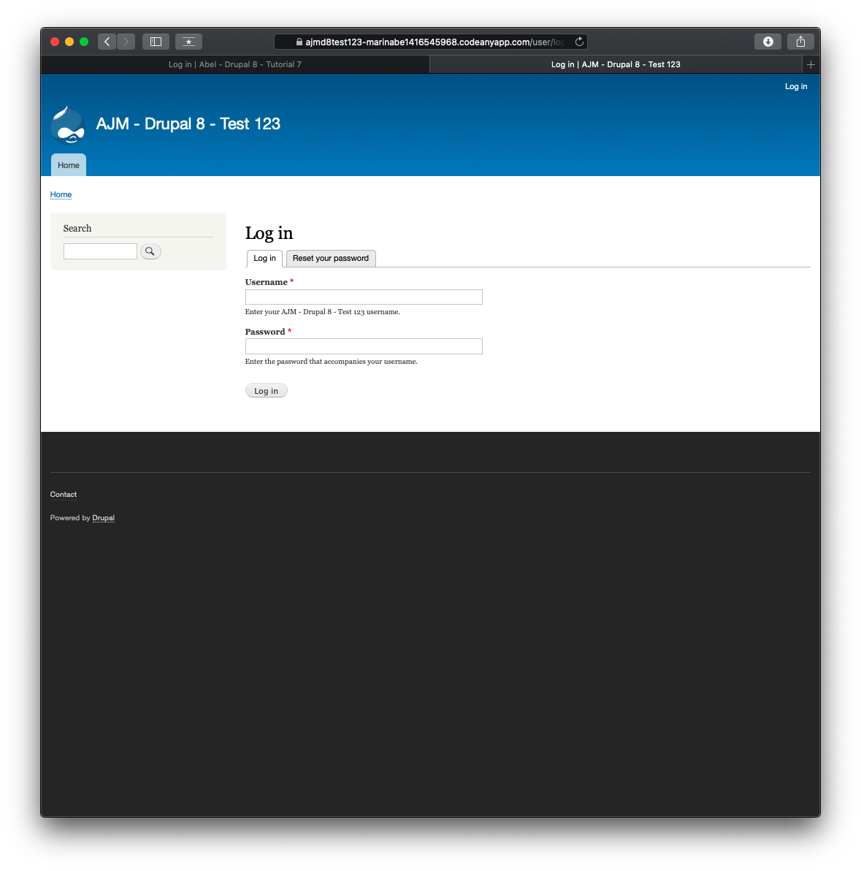]

Go back to the instructions and continue at Part I.